Combinational Circuit Synthesis
John F. Wakerly – Digital Design. 4th edition. Chapter 4.

- Goal – Represent the technic of schematic synthesis.
- Learning outcome - by the end of this class the students should be able to create a schematic of any 4 variable Boolean function (minimized and not minimized).

A logic function can be represented in several different forms:

- Truth table representation
- Boolean equation
- Circuit schematic
- Map (Karnaugh)

The main goal of hardware synthesis is to create reduced and minimized schematics for these combinational expressions.
The minimized function often reveals information that is not apparent from a non-minimized form.
We will use two so called canonical forms: sum-of-products (SOP) and product-of-sums (POS)
The AND operation is taken as a Boolean product and the OR operation represents the Boolean sum.

We will design some useful circuits using the basic logic gates, and use these circuits later on as building blocks for more complicated circuits.

The following steps are a useful formal approach to combinational problems:

1. Devise a truth table of the independent input variables and the resulting output quantities.
2. Write Boolean algebra statements that describe the truth table.
3. Reduce the Boolean algebra.
4. Mechanize (implement) the Boolean statements using the appropriate logic gates.

1. Devise a truth table of the independent input variables and the resulting output quantities.
Let’s take the f11 switching function from the previous class.

A B  0 0  0 1  1 0  1 1 | f(A,B)  1  1  0  1

2. Write Boolean algebra statements that describe the truth table.

f₁₁(A,B) = AB + A'B + A'B'

3. Reduce the Boolean algebra.

f₁₁(A,B) = A' + B
 | A’ | A
B’ | 1 | 0
B | 1 | 1

4. Mechanize (implement) the Boolean statements using the appropriate logic gates.

We can use below pictures of basic gates to make easy our work.

&  AND  &  NAND  ⊕  XOR  ⊕  NXOR | 1  OR  1  NOR  NOT

Here is the combinational minimized circuit implementing the function f₁₁(A,B) = A' + B.
_
0 0 1 1 A 1 1 0 0
1
A 1 1 0 1
f₁₁(A,B) = A' + B

0 1 0 1
B

Below is the Timing Diagram of the circuit without propagation delay.

A

0 0 1 1 0

A’

1 1 0 0 1

BA

0 1 0 1 0

FA

1 1 0 1 1

_
0 0 1 1 A 1 1 0 0
1
A 1 1 0 1
f₁₁(A,B) = A' + B

0 1 0 1
B

Here is the Timing Diagram of the same circuit but with propagation delay in both gates.

A

0 0 1 1 0

A’

1 1 0 0 1

BA

0 1 0 1 0

FA

1 1 0 1 1
Glitch

Here is the combinational not minimized circuit implementing the function
f₁₁(A,B) = AB + A'B + A'B'
__
A _
1
&
&
&
A A B

A B

_ _
A B
__
B
B
Signal passes from left to right

- Inputs of gates are from left side, the outputs – to the right side.
- If the lines are merged then there have to be put a filled circle on the contact point of lines.
- If the lines are crossed without contacting then there should not be a contact point.

Deriving the XOR Function

We stated that the Exclusive-OR, or XOR function can be described verbally as, "Either A or B, but not both." In the realm of digital logic there are several ways of stating this in a more detailed and precise format. We won't go here into such devices as Truth tables and graphic representations. We will stick with the more complete verbal statement, "NOT A and B, or A and NOT B."

From the truth table
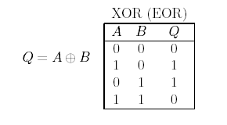 | 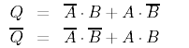

We will use this equation:
and we can draw the mechanization
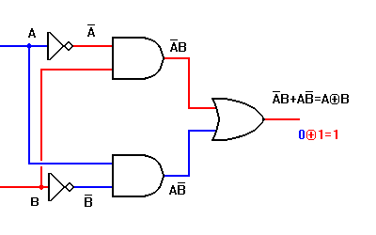

- We can begin from the end of circuit creating first the OR gate (“+”)
- then creating AND gates
- and finally create two invertors to invert the A and B

- Or we can begin from the creating initial buses and circuits for Boolean variables A and B
- And get their inverted values
- Then based on A, B and A’, B’ values create the AND gates.
- The last gate will be the OR gate combining both AND gates.

Creation of Combinational Circuit on particular basic gate

The practical problem with the circuit above is that it contains three different kinds of gates: AND, OR, and NOT. While this illustrates a practical application using all three of the basic gate types, it is cumbersome to construct on a printed circuit board.

There are commercial packages which contain four XOR gates, but often only a single XOR function is wanted in a given application. What is also wanted is a way to create that function with a single IC package.

This can easily be done with a single quad two-input NAND gate, as shown in the circuit below:

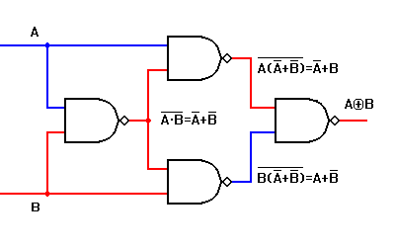
To build any complex circuit based on any simple gate we have to transform the formula of circuit mathematically using Boolean algebra and express whole formula by appropriate gate function.
Using this way we can create any circuit based on NAND, NOR ….

_ _ _ _ _ _ _ _ _ _ _ _ _ _
A B + A B = A B + A B = A B A B = (A+B) (A+B) = AA + AB + BA + BB = AB + AB =

___ _ _ ___ _ _ ___ ___ __ __
= AB AB = AB ( A + B) = AB (A + B) = AB (A + B) = ABA + ABB =

__ __
= ABA ABB

_ _ _ _ _ _ _ _ _ _ _ _ _ _
A B + A B = A B + A B = A B A B = (A+B) (A+B) = AA + AB + BA + BB = AB + AB =

_ _
= (A+B) + (A + B)

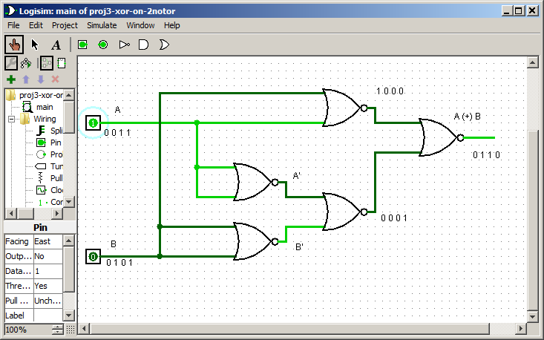

Two functions implementation

We have a truth table of F1 function of 2 input variables and another truth table of F2 function of 3 input variables. The problem is to synthesize combinational logic for two functions implementation.

A B  0 0  0 1  1 0  1 1 | F1(A,B)  F1(A,B) = AB + A'B'  1  0  0  1

A B C  0 0 0  0 0 1  0 1 0  0 1 1  1 0 0  1 0 1  1 1 0  1 1 1 | F2(A,B,C)  0  1  F2(A,B,C) = ABC + A’BC + A'B’C = C (B+A’)  0  1  0  0  0  1

We create the Buses for all possible variable values. All the schematic is created from left to right. Inputs of gates are from left side, the outputs – to the right side. Buses have enough length to allow all gates in schematic to be connected with them by direct lines.

_ _
A B C A B (Input Buses)
&
F2 = C (B+A’)

1
_
A + B

A B
&

1
_ _ F1=AB+A’B’
A B
&

BUSes – variable values in form of long lines
- They are placed to the leftmost part of schematic
- They supply all gates of schematic by variable values.
- They have to be enough long to allow gates to be connected by direct lines
- The initial buses are the buses only with true values. The false values are derived from the true values by inversion.

Two or more functions of the same variables are implemented on the same schematic. They use the same variables and as much common parts from schematic as possible. In above case there are no common parts.

Let’s implement another two functions which have the common part.

A B  0 0  0 1  1 0  1 1 | F1(A,B)  F1(A,B) = AB + A'B'  1  0  0  1

A B C  0 0 0  0 0 1  0 1 0  0 1 1  1 0 0  1 0 1  1 1 0  1 1 1 | F2(A,B,C)  0  F2(A,B,C) = ABC + A'B’C= C (AB +A’B’)  1  0  0  0  0  0  1

_ _
A B C A B (Input Buses)
&
F2=C(AB+A’B')

A B
&

1
_ _ F1=AB+A’B’
A B
&

